博客素材：
https://zhuanlan.zhihu.com/p/62943622

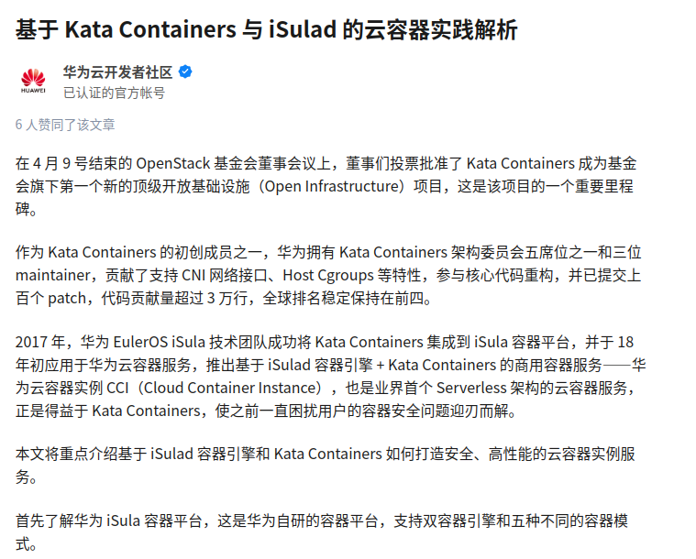
https://www.donews.com/news/detail/4/3097937

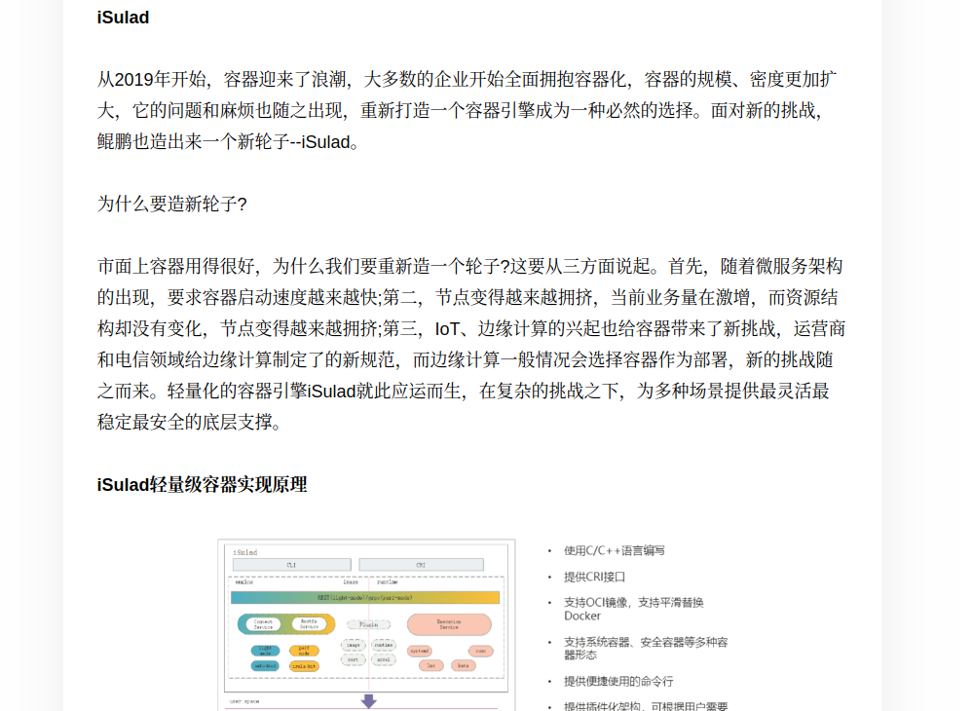
https://www.cnblogs.com/huaweicloud/p/12525383.html

